Introduction

Prediction models were made to predict the price of the stock of Microsoft Corporation for the next 30 days. In this document the prediction generated by the ARIMA and LSTM model is compared to the prediction model currently used in the industry. Same data was used for both the models to predict the future stock price.

ARIMA Model Prediction

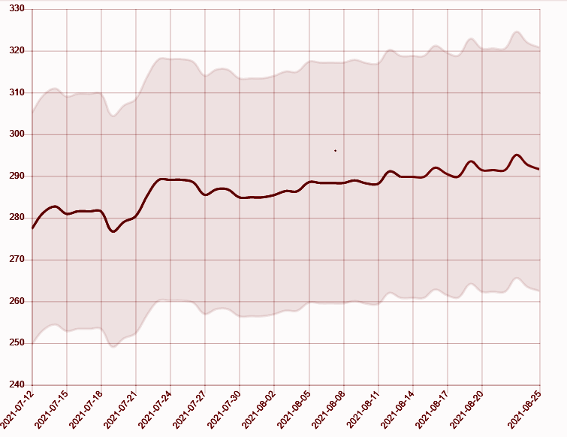

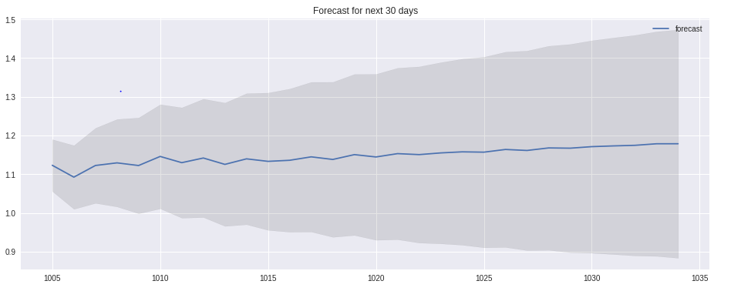

This is the my prediction of ARIMA model for microsoft corporation against the prediction by GOV CAPITAL

<https://gov.capital/stock/msft-stock/> for the date from 18/07/2021 to 25/08/2021.

LSTM Model Prediction

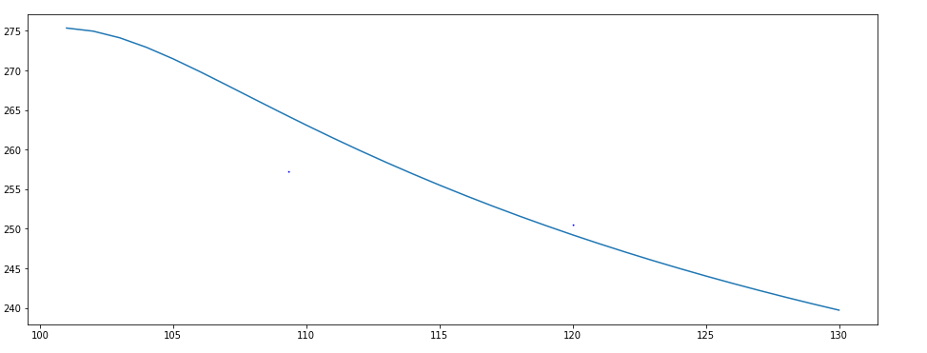

This is the my prediction of LSTM model for microsoft corporation against the prediction by GOV CAPITAL

<https://gov.capital/stock/msft-stock/> for the date from 12/07/2021 to 25/08/2021.

In my prediction model the value of stock has dropped from value of 275 to 240.

All the images are individually attached below for a clear look at each graph.

Individual Images

Prediction of GOV CAPITAL



Prediction using LSTM Model.



Prediction using ARIMA Model.

